7-5–17 NetSuite Punch List (UPDATE)

1. Pulling new lot numbers while old lot numbers are still available.

Robert: Script updated, Test & Verify this in the sandbox.  
(see saved search: “SDM - Available Lot Search by Item” as a quick way to see what lots are available by filtering by item)

1. After overriding lot number, expirations date is not changing to new expiration date. Cannot fix the expiration date after override.

Robert: Script updated, Test & Verify this in the sandbox.

1. ~~Lot number with multiple dates is showing as one lot.~~

Robert: This was removed from punchlist from conference call, not an issue.

1. Push invoices through to regular NetSuite.

Robert: Invoice form in production has been updated per Ginny’s request. (Catalog # space increased)

1. Set up Magento customer to “email invoice” as default function.

Robert: Namgyal working on, should be done next week. Its thru the Boomi integration. This is for Invoice or CC cash receipt.

1. Comments are not printing on packing list.

Robert: I need more specificity or an example. I’m not sure exactly what field is meant by “comments” that should be appear in the last column on the Packing Slip.

1. “Email sales” order does not work.

Robert: I tested the “To Be Emailed” checkbox on the Sales Order int he sandbox and it worked. Are there any instances of this occuring in the sandbox? Has Vector checked the “Bounced Email Addresses” page to make sure no customers have accidentally been flagged as spam?

1. Report to show how many times we adjust inventory and/or lot number.

Robert: See the saved search, “SDM - Lot Changes on Sales Order” (it shows every Sales Order by Item & Lot whenever there was a change on the expiration date field)

1. Make “email invoice” as PDF default.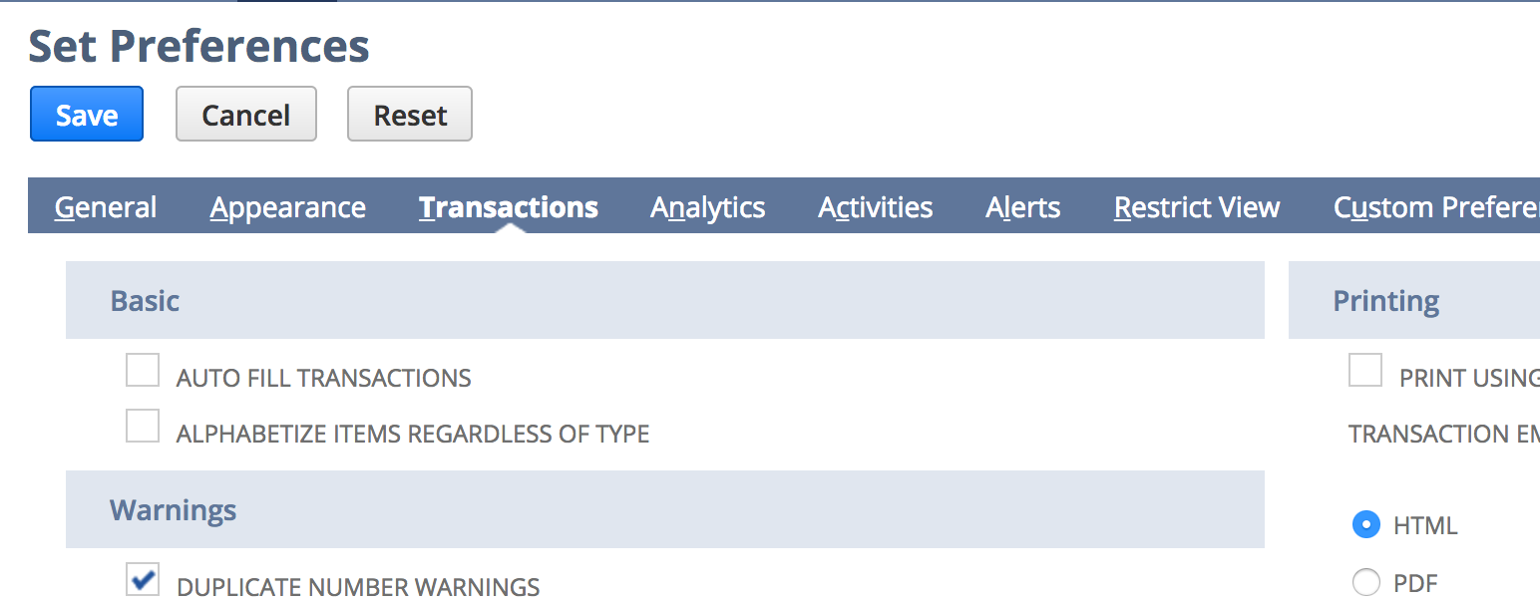

Robert: this can be overridden by the user’s settings. Have the Vector user with this problem move their mouse to the Home icon, then choose “Set Preferences”, then choose “Transactions” tab and under “Transaction Email Attachment Format” choose PDF.

If this doesn’t resolve the problem then Namgyal will create a workflow that automatically sets new customers to PDF for Invoice.

1. In sales order create 3 new fields:
   * Order placed by - purchasing agent placing the order? Need to add field. On customer record = create contact record. SDM’s custom contact record ties in the purchasing agent into the SO. Fields = Shuiptocontact & shiptocustomer. They want to tie related end user to the their Sales Order. Need to make another ShipToContact.  
     For every order who placed it & their phone number, and the end user.

* Contact phone number
* Enduser Name

Robert: Vector can tie the contact to the Sales Order by scrolling down on the Sales Order to the “Relationships” tab and adding a Contact there. The Contact’s role now has the options for “End User” or “Purchasing Agent.” This way, if the End User’s information is provided then Vector can get their email address, phone, title for marketing purposes and later reports can be run to see what the end user purchased providing there were entered in as a contact on the Sales Order record.